1. Number of iterations = 100  
   Least Squared Error for k = 10 is 2.4633e+02

Least Squared Error for k = 50 is 1.7422e+02

Least Squared Error for k = 100 is 1.3170e+02.

1. minErr = 0.8924

maxErr = 0.9300

average Absolute Error = 0.9070

1. Precision vs Recall Curve  
   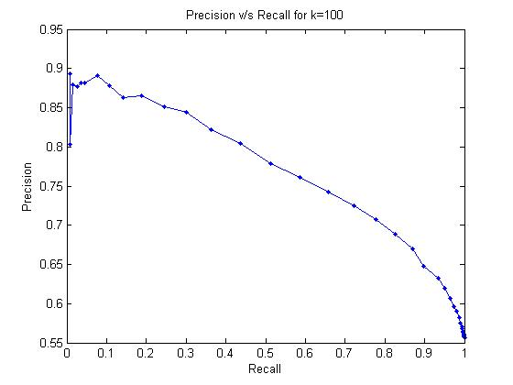
2. Least Squared Error for k = 100: 2.534044e+00